**Lab 4 Activity 2 - Slide Basics**

**Objective** - Develop students' ability to create slides with varying layouts, format text, and adjust alignment to improve readability and visual hierarchy

1. Add at least three slides with the following layouts: Title Slide, Content Slide, and Comparison.
   1. Title Slide: Add a presentation title and a subtitle.
   2. Content Slide: Add a bulleted or numbered list with at least five points.
   3. Comparison Slide: Use two content placeholders to compare two topics.
2. Insert and format text on each slide using the following:
   1. Font styles (e.g., Bold, Italic, Underline).
   2. Font sizes and colors for headings and body text.
3. Add visual hierarchy by using different font sizes and colors to distinguish headings from content.
4. Experiment with alignment (e.g., left, center, right, justify) for slide text to observe its effect on readability.

**____________________________________________________________________________________**

**Solutions:**

**Task 1:**

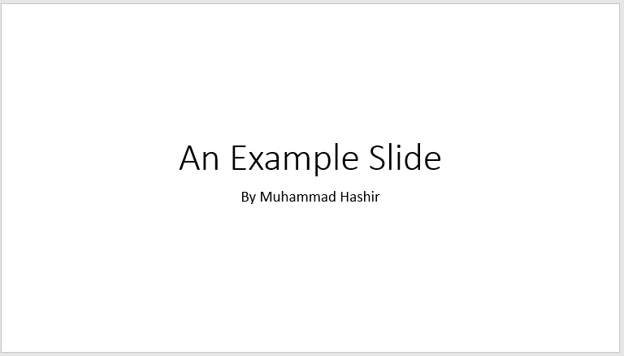

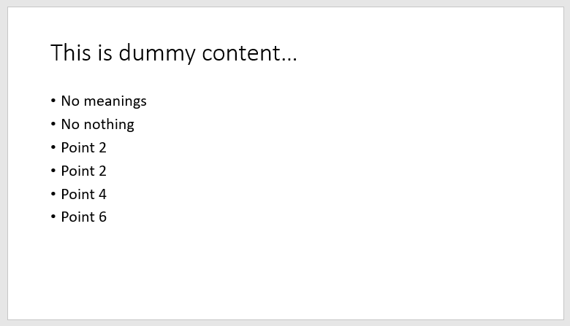

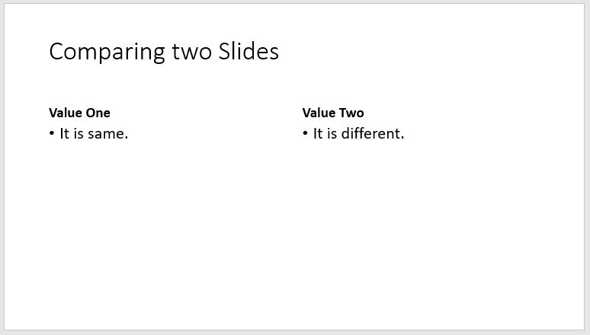

**Task 2:**

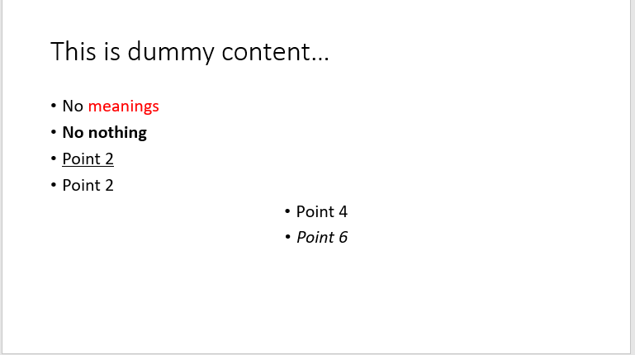

**Task 3:**



**Task 4:**

